
Welcome to English 8

During this course you will have many opportunities to learn and improve your skills in communication.

We will work through processes and activities that aim to enhance your writing, reading, speaking, listening, and viewing abilities. We will do this through 7 units of study. Each will entail several in class and homework assignments and will culminate with a unit exam.

Unit 1: Review Unit

During the writing unit you will be expected to participate in free-writing activities as well three times a week.

Unit 2: Short Stories

Read and enjoy short stories while enhancing your ability to understand the skills and techniques that author’s use to create. Through discussion, visual and written communication, you will continue to increase your capacity to integrate quotations from primary and secondary sources, and write analytically about the ideas presented.

Unit 3: Poetry

Poetic forms and devices, the connotations of language and the writer’s process through poetry will be further discovered, discussed and analyzed. Various activities will be incorporated so that you experience types of poems, poets, forms and presentation styles.

Unit 5: Novel Study-- The Outsiders

Here we will read a short novel and work together to analyze and discuss main ideas or concepts within the novel.

Christmas Break

Unit 6: Writing Unit #1

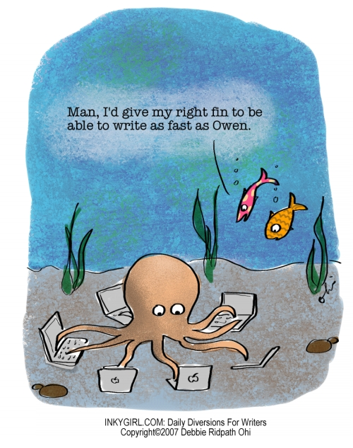
Developing one idea, adding details, using meaningful transitions, vivid verbs and adjectives, being persuasive, convincing others logically, comparing and contrasting…all of this happens in your writing unit. You will also be working on grammatically and mechanically sound skills, -remembering the purpose and power of all parts of speech and their interconnectivity to create the best writing possible.

Unit 7: Novel Study- Lit. Circles

You will be given five options for novels to read during this unit. You must choose one. You will then be placed in a group with other students who are reading the same novel as you. Your group will be responsible for reading the novel, completing assignments and giving a class presentation about your novel upon completion.

Unit 8: Writing Unit # 2

Unit 9: Review of Writing, Reading and Responding Skills/Strategies
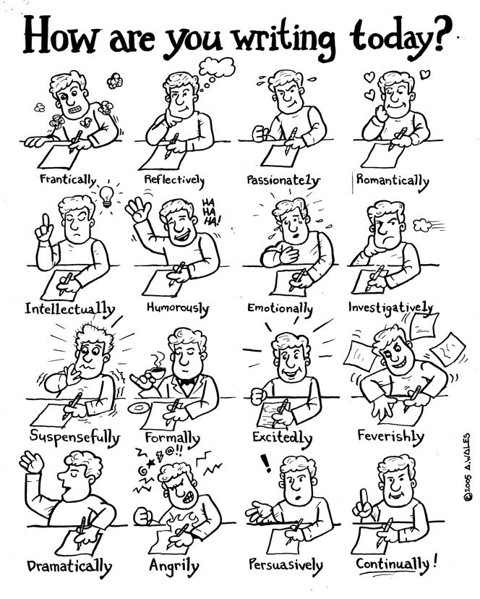
Independent Novel Study

Starting at the beginning of the course you will be able to choose a novel of their choice and they will be responsible for reading it and completing a independent novel study assignment. This is worth 20% of your grade.

Letter Grades

A | 86%-100%
B | 73%- 85%
C+ | 68%-72%
C | 60%-67%
C- | 50%-59%
I= incomplete | Failing---Gulp!! ☹

Plan Time To Succeed!
Evaluation:

You will earn a letter grade and percentage for each term, and a final grade for the course.

The mark breakdown may vary from unit to unit, dependent on the desired learning outcomes and the instructional strategies utilized. Nonetheless, a term breakdown should look like this:

Class work and major assignments | 30.00%
Homework (checks and assessments) | 20.00%
Tests/Quizzes | 30.00%
Independent Novel Studies | 20.00%
Course mark (80%) + Final Exam mark (20%)= 100%
If you are not meeting course expectations, you may also receive and “I” at some point in the course. This stands for “In Progress” or “Incomplete”, depending on the circumstances. The “I” is a warning that you are not meeting course expectations, and may not be successful in the course. Be aware that once an “I” has been given at any point in the semester or year, an “F” or failing grade can be issued on a formal report.

Academic Dishonesty:

The copying of another person’s files/data/information will not be tolerated. I have zero tolerance for plagiarism, which results in a zero on the assignment for ALL students involved and could possibly involve parents, counselors, and administration. Academic dishonesty and plagiarism breaks the trust between that instructor and student. In short, when in doubt about any work that you are doing and its source, ask your instructor!!

Absences

If you are home ill, your parents are responsible for informing the school that you are absent for the day.

You are responsible for completing all assignments that you miss due to absence. Talk to another students in the class or talk to me either before or after school.

If you miss three classes in a row I will contact your parents/guardians.

Let’s have an awesome year!

Ms. Taylor
sarah.taylor@yesnet.yk.ca

